PCB DESIGN & MANUFACTURING

DOCUMENT

DIGITAL TIMER

- SCOPE & OBJECTIVES:
- Translate the validated Tinkercad/Arduino prototype into a manufacturable PCB.
- Assign correct footprints, apply PCB design rules, and route the board.
- Generate 2D/3D views for mechanical checks.
- Create production files: Gerbers, drill, BOM, and assembly drawings.

- SCHEMATIC:
- KEY FUNCTIONAL BLOCKS:
Arduino Leonardo , sw push,d1 led, bt1 battery,output connection.
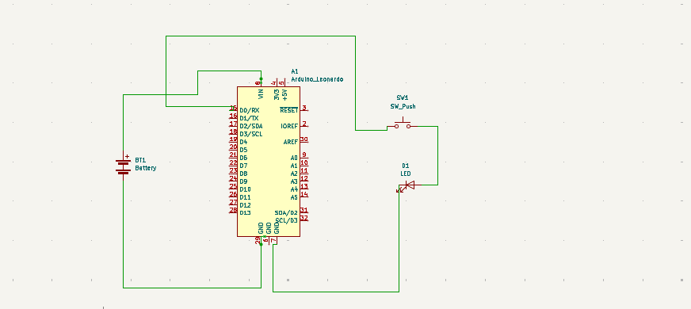

3.PCB LAYOUT- PLACEMENT & ROUTING
- Board Outline: Rectangular PCB sized to host Arduino Leonardo footprint and battery holder.
- components: Arduino Leonardo , sw push,d1 led, bt1 battery,output connection.
- The connections are fix properly to form the PCB
- The PCB model is done and work by using kicard.
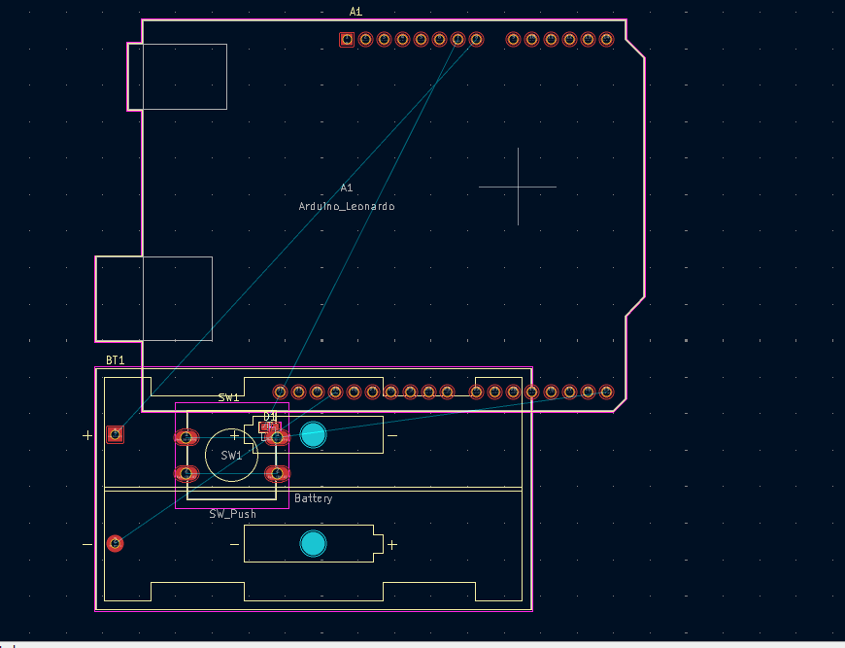

4.FOOTPRINT ASSIGNMENT & PCB DESIGN RULES (DRC):

REFERENCE | FOOTPRINT | NOTES
Arduino Leonardo | Module:Arduino_UNO_R3 | Mounting holes aligned to UNO
sw push | Battery: BatteryHolder_Keystone_2462_2xAA | Mountain by both led and arduino
d1 led | LED_SMD:LED_0603_1608Metric | Mountain in both arduino and sw push
bt1 battery | Button_Switch_THT:SW_PUSH-12mm | Both +ve and –ve is connected in arudino
5.2D/3D PCB VIEWS & FINAL CHECKS:
- 3D fit: Verify battery holder, UNO headers, and connectors clearance
- Mounting holes: Ardunio, led ,sw push.
- Test points: Provide for positive connected in VIN , negative connected in GND .
- DRC: Run full rule check; fix unconnected nets, short circuits, and silkscreen overlaps.

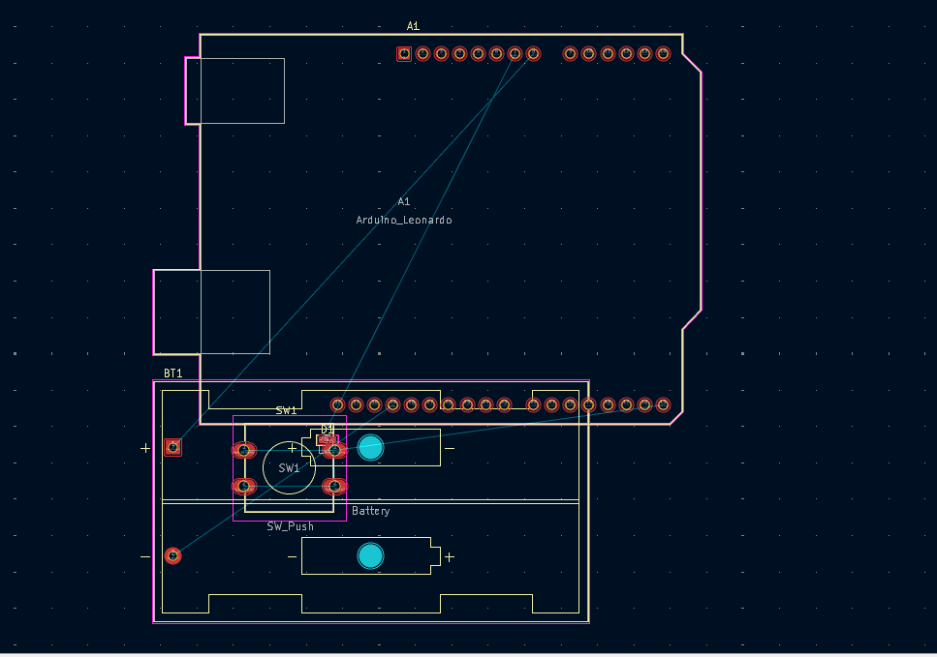

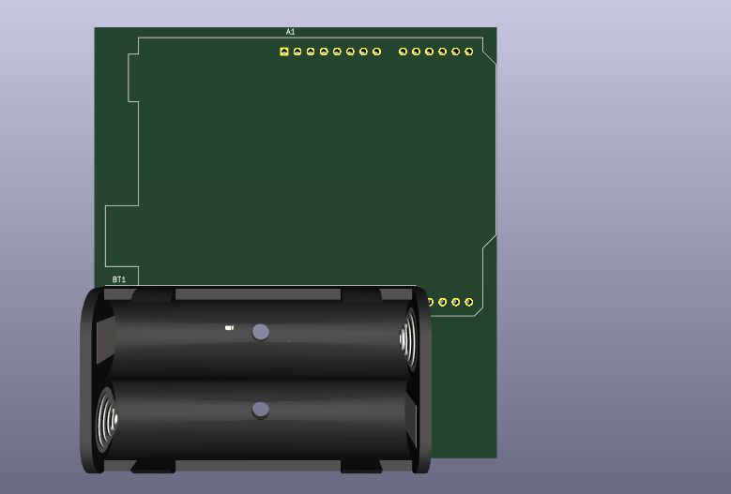

6. production files(fabrication & assembly):

- Component Sourcing & PCB Assembly:
  - Gathering ICs (like 555, counters), transistors, diodes, resistors, capacitors, crystals, and displays (LED/LCD).
  - Placing and soldering these onto a printed crituit board (PCB) according to circuit design, ensuring stable oscillator circuits.
- Testing Electronic Assembly:
  - Testing the assembled PCBs for performance before final integration to ensure accuracy and reability
3.Electro-Mechanical Assembly:
  - Attaching physical parts like buttons, switches, connectors, and terminal blocks to the housing or front panel.
4.Final Assembly & Integration:
  - Combining the tested electronic circuit board with the mechanical parts to form the complete, compact digital timer unit.
5.Calibration & Quality Control:
  - Ensuring precise timing, checking different modes (On-Delay, Off-Delay, Cyclic), and verifying output functions (relays, switches).

7.BILL OF MATERIAL:

NAME | QUANTITY | COMPONENT
U1 | 1 | ARDUINO UNO R3
U3 | 1 | MCP23008-based,32(0x20)LCD16(12C)

